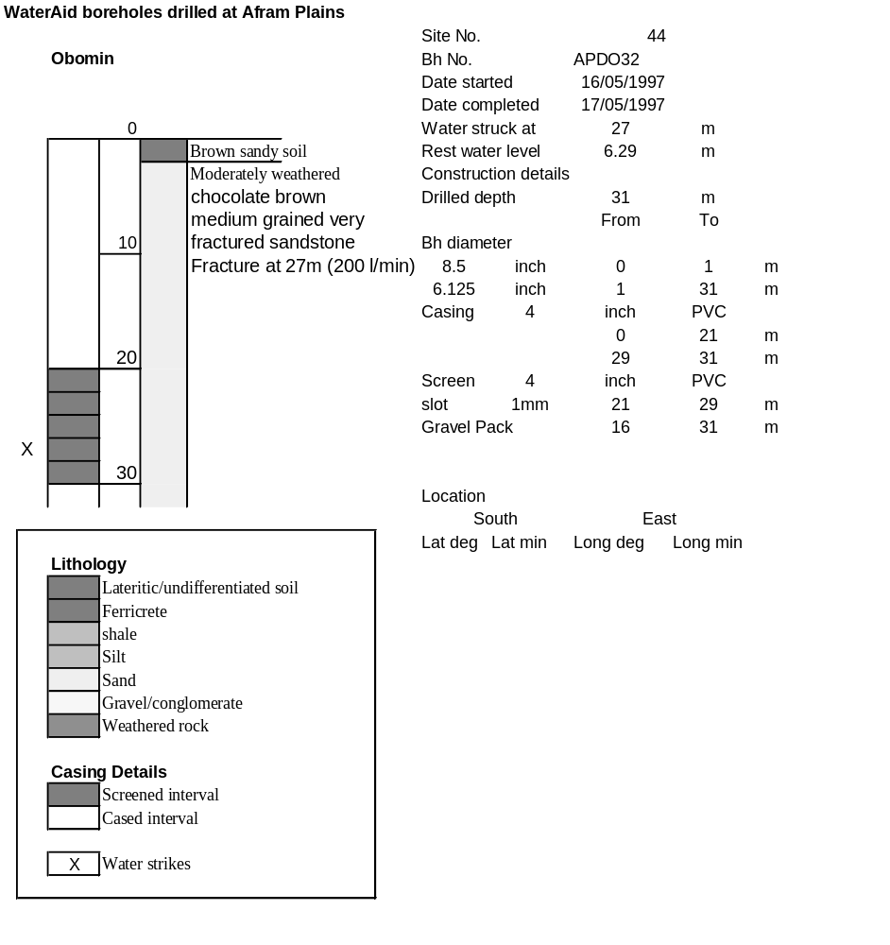

Ghana | Test pumping
Borehole No. |  | APDO 32
Hole No |  | 44
Village |  | Obomeng
Date |  | 12/06/1997
Point below GL |  | 0.39 | m
Pump depth |  | 21 | m
SWL |  | 6.29 | m
Start Time |  | 23:00
Drawdown test |  |  |  |  | Recovery Test
time | pwl (m) | Q l/min | dd | sc(q/s) | Time | wl (m) | t/t' | resdd
0.00 | 6.29 | 75.00 | 0.00 |  | 0.00 | 7.43 |  | 1.14
1.00 | 6.52 | 75.00 | 0.23 | 326.09 | 1.00 | 6.81 | 181.00 | 0.52
2.00 | 6.61 | 75.00 | 0.32 | 234.38 | 2.00 | 6.82 | 91.00 | 0.53
3.00 | 6.63 | 75.00 | 0.34 | 220.59 | 3.00 | 6.76 | 61.00 | 0.47
4.00 | 6.79 | 75.00 | 0.50 | 150.00 | 4.00 | 6.74 | 46.00 | 0.45
5.00 | 6.79 | 75.00 | 0.50 | 150.00 | 5.00 | 6.74 | 37.00 | 0.45
6.00 | 6.79 | 75.00 | 0.50 | 150.00 | 6.00 | 6.72 | 31.00 | 0.43
7.00 | 6.79 | 75.00 | 0.50 | 150.00 | 7.00 | 6.70 | 26.71 | 0.41
8.00 | 6.79 | 75.00 | 0.50 | 150.00 | 8.00 | 6.70 | 23.50 | 0.41
9.00 | 7.03 | 75.00 | 0.74 | 101.35 | 9.00 | 6.70 | 21.00 | 0.41
10.00 | 7.01 | 75.00 | 0.72 | 104.17 | 10.00 | 6.69 | 19.00 | 0.40
12.00 | 7.08 | 75.00 | 0.79 | 94.94 | 12.00 | 6.68 | 16.00 | 0.39
14.00 | 7.11 | 75.00 | 0.82 | 91.46 | 14.00 | 6.68 | 13.86 | 0.39
16.00 | 7.11 | 75.00 | 0.82 | 91.46 | 16.00 | 6.68 | 12.25 | 0.39
18.00 | 7.12 | 75.00 | 0.83 | 90.36 | 18.00 | 6.68 | 11.00 | 0.39
20.00 | 7.12 | 75.00 | 0.83 | 90.36 | 20.00 | 6.67 | 10.00 | 0.38
25.00 | 7.13 | 75.00 | 0.84 | 89.29 | 25.00 | 6.66 | 8.20 | 0.37
30.00 | 7.13 | 75.00 | 0.84 | 89.29 | 30.00 | 6.66 | 7.00 | 0.37
35.00 | 7.16 | 75.00 | 0.87 | 86.21 | 35.00 | 6.64 | 6.14 | 0.35
40.00 | 7.17 | 75.00 | 0.88 | 85.23 | 40.00 | 6.64 | 5.50 | 0.35
45.00 | 7.19 | 75.00 | 0.90 | 83.33 | 45.00 | 6.64 | 5.00 | 0.35
50.00 | 7.19 | 75.00 | 0.90 | 83.33 | 50.00 | 6.63 | 4.60 | 0.34
60.00 | 7.20 | 75.00 | 0.91 | 82.42 | 60.00 | 6.62 | 4.00 | 0.33
70.00 | 7.21 | 75.00 | 0.92 | 81.52 | 70.00 | 6.61 | 3.57 | 0.32
80.00 | 7.24 | 75.00 | 0.95 | 78.95 | 80.00 | 6.61 | 3.25 | 0.32
90.00 | 7.26 | 75.00 | 0.97 | 77.32 | 90.00 | 6.61 | 3.00 | 0.32
100.00 | 7.28 | 75.00 | 0.99 | 75.76 | 100.00 | 6.60 | 2.80 | 0.31
110.00 | 7.29 | 75.00 | 1.00 | 75.00 | 110.00 | 6.59 | 2.64 | 0.30
120.00 | 7.35 | 75.00 | 1.06 | 70.75 | 120.00 | 6.58 | 2.50 | 0.29
140.00 | 7.40 | 75.00 | 1.11 | 67.57
160.00 | 7.41 | 75.00 | 1.12 | 66.96
180.00 | 7.43 | 75.00 | 1.14 | 65.79

